6th Annual NeFarmTok Golf Tournament
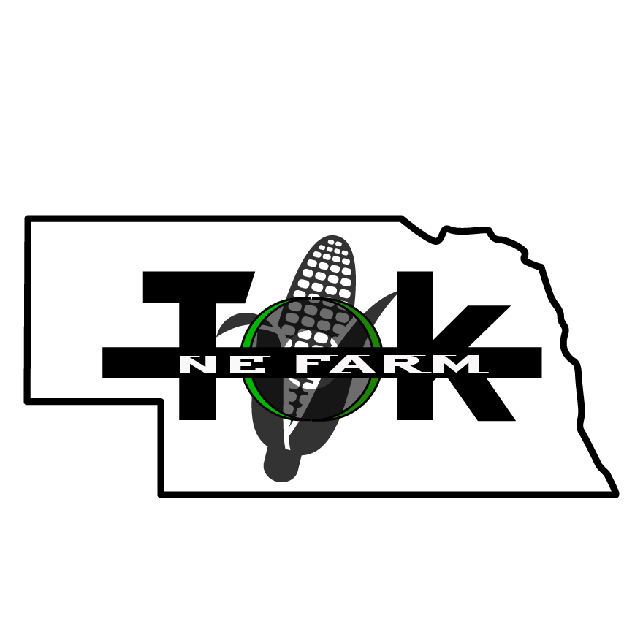
Steeple View Golf Course
27068 467 Street, Humphrey NE 68642

Saturday, July 11, 2025 9:00 AM
9 Hole – 4 Person Scramble

This fundraiser is hosted by NeFarmTok, Inc. to provide financial support to those individuals across Nebraska that have endured a life changing event
And
To assist our rural communities across Nebraska with the financial support they need to help recover from or respond to the needs of the local population.

TOURNAMENT IS LIMITED TO 36 TEAMS! REGISTER EARLY TO SAVE YOUR SPOT!
Consider the following ways to participate:

Early Bird Discount Deadline – June 15th Final Registration Deadline July 8th
_______ Team Entry: $320 (Early Bird) $400 (After June 15th)
4 golfers – 9 holes – cart, fees, lunch included

_______ Prize Money Increase: $100 Deadline – June 15th
Donate Prize or Money in the value of $100
Prize Money Donors will be recognized in tournament brochure

_______ Flag Prize: $50 Deadline – July 1st
Donate Prize or Money in the value of $50
Flag Donors will be recognized in tournament brochure

Business Name:___________________________ Business Website:__________________________
Golfer 1.____________________________ Golfer 2.____________________________
Golfer 3.____________________________ Golfer 4.____________________________
Contact Person:______________________________ Phone: ___________________________________
Address:_________________________City, State:_______________________ Zip Code:_________________
Email:________________________________
Mail completed form and payment to: _______Cash _______Check
NeFarmTok
40449 280th Ave Amount Enclosed: $_____________
Humphrey NE 68642
Or
Email pre-registration to:
cyndischure70@gmail.com

TO RECEIVE EARLY BIRD DISCOUNT ENTRY FEE MUST BE PAID BY JUNE 15, 2026

