NeFarmTok
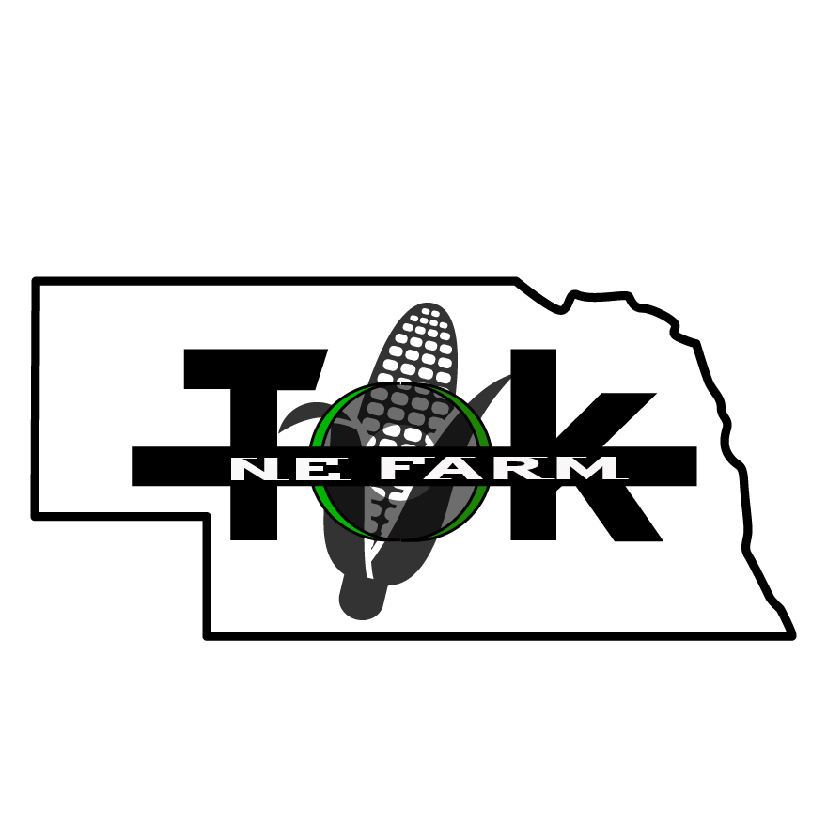
40449 280th Ave
Humphrey NE 69642

6th Annual NeFarmTok Golf Tournament

NeFarmTok’s 6th Annual Golf Tournament at Steeple View Golf Course in Humphrey Ne on July 11, 2026. We look forward to another amazing turnout. We will be offering pre registrations for Golf, please watch our website www.nefarmtok.com this spring for information on registering.

To all previous sponsors we would like to Thank You! for your sponsorships of NeFarmTok’s tournaments. First time sponsors we would like to invite you to partner with us in helping Nebraskans.

For the 2026 event we are offering various levels of sponsorship for our annual fundraiser. Size and placement of logos on flyers, brochures and website are based on sponsorship level (one business per sponsorship please).

Platinum Sponsor  Over $1,000  - Logo on large tournament banner  - Logo on Flyers  - Logo on Website and Facebook Page  - Logo listed on Tournament Brochure  - Name mentioned in radio ads | $500 Diamond Sponsor  - Logo on large tournament banner  - Logo on Flyers  - Logo on Website and Facebook Page  - Logo listed on Tournament Brochure | $300 Gold Sponsor  - Logo on large tournament banner  - Name on Flyers  - Name on Website and Facebook Page  - Name listed on Tournament Brochure
$200 Silver Sponsor  - Name listed on tournament banner  - Name listed on Flyers  - Name listed on Website and Facebook Page | $100 Bronze Sponsor  - Name listed on Website and Facebook Page  - Name listed on Flyers

Thank you for partnering with us! We look forward to working together!

Cyndi Schure, NeFarmTok President

